Lower Mustang – Kagbeni | ~2,800–3,800m
General Overview Factsheet
Planetary Health Transect
Landscape
Geography & Landscape  Kagbeni (2,804m) sits at the confluence of the Kali Gandaki and Jhong (Kag) Khola rivers at the northern boundary of Lower Mustang — the gateway to the restricted Kingdom of Lo. Enclosed between Dhaulagiri (8,167m) to the west and the Annapurna massif (8,091m) to the east, the Kali Gandaki gorge — the world's deepest canyon — cuts through this transition zone between Nepal's mid-hills and the Trans-Himalayan plateau.  The landscape is an arid rain-shadow desert: stratified ochre, pink, purple, and grey eroded cliffs frame irrigated river terraces that appear as vivid green oases. Annual precipitation ~250–300mm — significantly higher than Upper Mustang (~200mm) but still classified as a high-altitude arid zone. The Baragaon sub-region ("Twelve Villages") spans the transition between Thakali Thak and the Loba Lo cultures, combining elements of both.  The Kali Gandaki riverbed here is geologically unique: 200-million-year-old Shaligram ammonite fossils erode from the Tethys Sea shales and are collected as sacred objects by Hindu and Buddhist pilgrims. Muktinath temple (3,760m), 20km northeast, is one of South Asia's most important pilgrimage sites for both traditions. | 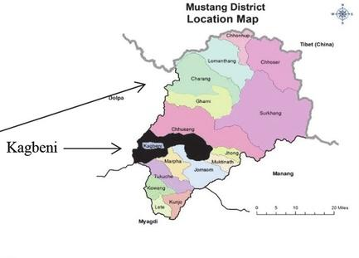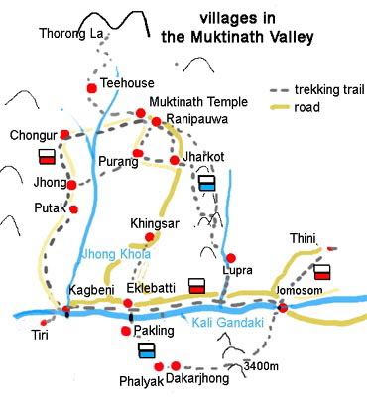
Demographics & Communities
Key Statistics  - Population: ~600 in Kagbeni village (2011 census); Gharapjhong Rural Municipality ~8,000; Baragung Muktichhetra Rural Municipality ~3,500  - Kagbeni village area: 58.3 km²; elevation 2,804m  - Mustang District total population: 14,452 (2021 census)  - Ethnicity: Baragaonle (Tibetan-Bhotiya) in Kagbeni; Thakali dominant south to Jomsom; Gurung and Brahmin-Chhetri in-migrants post-road  - Primary religion: 75% Buddhist, 25% Hindu (district); Kagbeni uniquely serves both Hindu and Buddhist pilgrimage traditions  - Literacy rate: ~70% (district level); female literacy lower due to seasonal migration patterns  - Primary occupations: agropastoralism, pilgrimage tourism, trans-Himalayan trade (historically), hospitality | 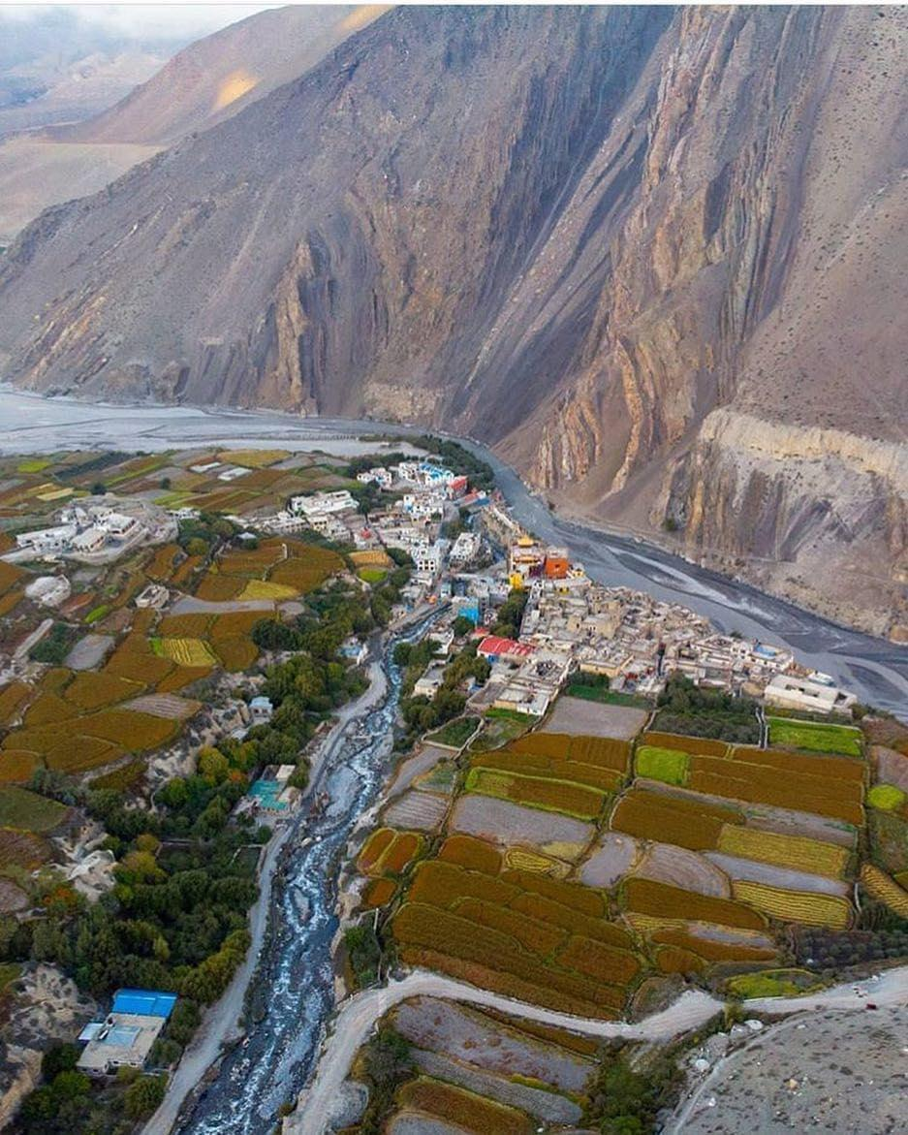Kagbeni medieval village at confluence of Kali Gandaki and Jhong Khola rivers.

People & Ethnicity
Indigenous Group: Baragaonle ("People of Baragaon") — culturally Tibetan-Buddhist, bilingual in Tibetan and Thakali-derived dialects; sometimes called Glo Bosmad ("Lower Lo")  Southern Group: Thakali — dominant from Jomsom south; synthesis of Tibetan and Nepalese culture; speak Thakali (Tibeto-Burman)  In-Migrant Groups: Gurung, Brahmin–Chhetri, lowland Nepali — arrived after road access (2008–2015)  Note: Baragaon comprises 19 villages including Kagbeni, Jharkot, Muktinath, Jhong, Lubra, Tangbe, and Chhusang. The Baragaonle share cultural similarities with Loba (Upper Mustang) but often adopt Gurung, Bista, or Thakuri surnames for social mobility. The 2023 flood devastated Kagbeni's Ward 4, displacing 35 families; government relief remained largely absent months later. | 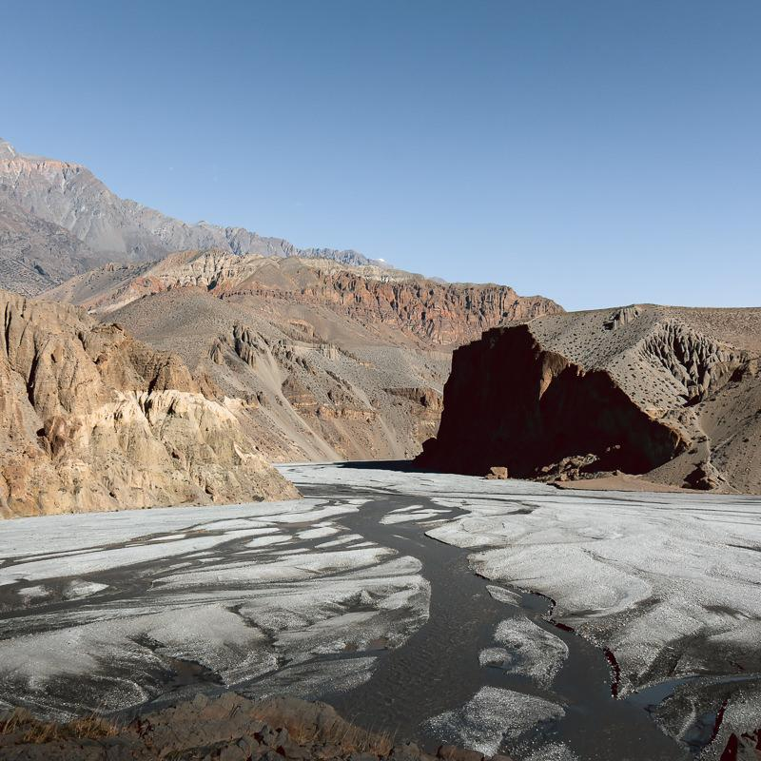Ochre cliffs and river

Historical Context — Key Events
Period | Event
12th c. | Kagbeni established as the gateway checkpoint to the Kingdom of Lo. Position at the Kali Gandaki–Jhong Khola confluence makes it a key node on trans-Himalayan salt-grain trade route linking Tibet to Indian markets.
1429 | Kag Chode Thupten Samphel Ling Gompa ("Red Monastery") founded in Kagbeni — still active, now serves as an educational centre for monks from Mustang, Dolpo and Manang since 2009.
1950s–60s | Tibet border closed. Trans-Himalayan salt trade collapses. Kagbeni and Baragaon communities shift from trade to agropastoralism and begin seasonal out-migration to hill markets.
1992 | Mustang opened to controlled international trekking. Kagbeni becomes the official checkpoint — the last free-access point before the restricted Upper Mustang zone. Annapurna Circuit trekkers begin passing through in large numbers.
2008–2015 | Jomsom–Kagbeni road completed (2008); full jeep road to Lo Manthang (2015). Journey from Pokhara: 4-day trek → 1-day jeep drive. Domestic pilgrimage tourism to Muktinath surges. Hotels, shops, and concrete construction rapidly expand outside traditional mud-brick boundaries. Kingdom of Lo formally abolished (2008).
13 Aug 2023 | Catastrophic landslide dam-burst flood on Jhong Khola destroys 29 buildings, 4 bridges, police post, schools, and infrastructure worth ~USD 7.4 million. 35 families displaced. No fatalities due to community early warning. Government relief largely absent months later. Flood signals the northward advance of Arabian Sea monsoon — unprecedented in this rain-shadow zone.

Climate Trends (1970–2019)
Kagbeni sits at the transition between Thak Khola and the Trans-Himalayan Arid Zone — warming faster than Nepal's national average
- Temperature rising at +0.07–0.09°C/year — among Nepal's fastest warming zones (3× the global average of 0.02°C/yr)
- Precipitation: ~250–300mm/year historically; trend uncertain — the 2023 flood signals Arabian Sea moisture now penetrating rain-shadow zones
- Winters warming faster than summers; reduced snowpack threatens spring irrigation supply
- Nepal warms at 0.056°C/year nationally — nearly 3× the global average (0.02°C/year)
- Critical new threat: Arabian Sea warming is pushing monsoon clouds northward, creating flash-flood risk in an area historically protected by rain-shadow geography
- Glacier retreat in Annapurna catchment reducing Kali Gandaki baseflow — threatening Shaligram fossil bed exposure and pilgrimage access

Lower Mustang – Kagbeni
Planetary Health Factsheet
Planetary Health Transect
Biodiversity
Fauna (Animal)  - ~150 bird species in the broader Mustang–Kali Gandaki corridor; ~28 mammal species  - Snow Leopard, Himalayan Wolf, Blue Sheep (Bharal), Tibetan Kiang — present from mid-altitudes upward  - Lammergeier, Himalayan Griffon vulture; Kali Gandaki gorge is a globally significant raptor migration corridor  - House Crow range-expansion documented advancing upward — biological indicator of climate warming  - Snow Trout (Schizothorax) in Kali Gandaki — declining due to GLOF-driven sediment pulses and altered hydrology  - Kali Gandaki Shaligram ammonite fossil beds: unique geological–ecological heritage linked to 200-million-year Tethys Sea formation | 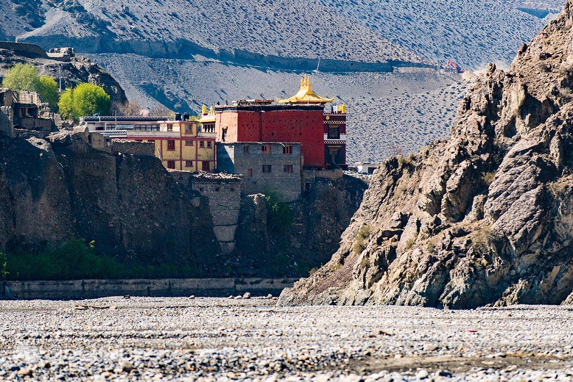 Kag Chode Red Monastery, Kagbeni

🌾 Crops  Barley, buckwheat,  potato, apple,  turnip, mustard.  Single cycle: Apr–Sep. | 🏡 Farm Structure  Smallholdings <0.5ha.  Subsistence & tourism-  linked commercial.  Apple orchards key. | ⚠ Climate & Access  Flash floods, hailstorms,  drought cited by >60%  of farmers. No agri  extension services.

Flora (Plant)  - 78+ vascular plant species recorded in Kagbeni and immediate surroundings (botanical survey); 180+ across broader Mustang District  - Sub-desert dwarf scrubland dominates: Caragana, Artemisia, Ephedra — same assemblage as Upper Mustang  - Irrigated oasis vegetation: barley, buckwheat, potatoes on river terraces; apple and apricot orchards  - Apple orchards especially productive at Marpha–Kagbeni belt — key cash income; branded 'Mustang Apple'  - Juniper woodland above 4,000m; alpine meadows above 4,500m toward Muktinath  - Invasive species pressure increasing from south as road traffic brings seeds and disturbs soils | Agriculture  - Single crop cycle: Barley–Buckwheat–Potato (Apr–Sep); apple and apricot as cash crops  - Smallholdings <0.5ha; both subsistence and commercial tourism-linked production  - Traditional water-sharing systems (analogous to Upper Mustang Ghenba) mediate irrigation rights  - Apple production at Marpha is Nepal's highest-profile mountain orchard cluster — increasingly threatened by erratic spring frosts  - Pilgrim demand (Muktinath visitors 200,000+/year) creating new market for local food products
Planetary Health — Key Themes
① Urbanization & Pollution
The completion of the Jomsom–Kagbeni road (2008) and the Beni–Jomsom–Kora La highway (2015) transformed Kagbeni from a trekking waypoint to a mass-tourism destination. Domestic pilgrimage traffic to Muktinath now numbers in the hundreds of thousands annually. What were once dedicated foreign trekkers are now joined by buses of Indian and Nepali pilgrims and tourists who arrive in hours rather than days.  The old mud-brick medieval town — with its 12th-century layout of narrow alleys, tunnel-like passages, and flat-roofed Tibetan-style houses — now sits alongside rapidly expanding concrete hotels, shops, and restaurants in incompatible styles. Infrastructure cannot keep pace: sewage treatment is entirely absent, with waste flowing directly into the Kali Gandaki. River contamination is rising in step with guesthouse proliferation. The ancient town's mud walls, which survived centuries in a dry climate, are now eroding under increased rainfall from shifted monsoon patterns.  Water Pollution: Kagbeni lacks sewage infrastructure. Fieldwork (Mongabay, 2024) confirmed raw sewage entering the Kali Gandaki directly from guesthouses. No systematic water quality testing post-2023 flood — arsenic and fecal contamination risk elevated as riverbed was massively disturbed. | 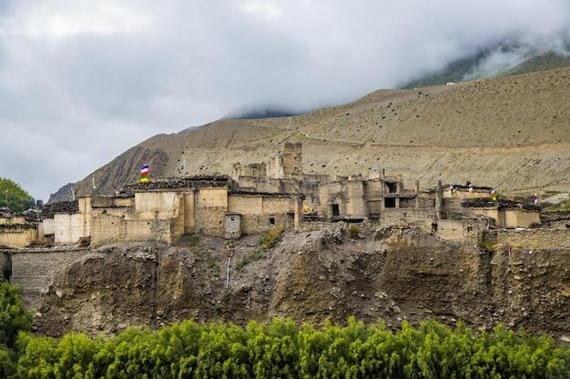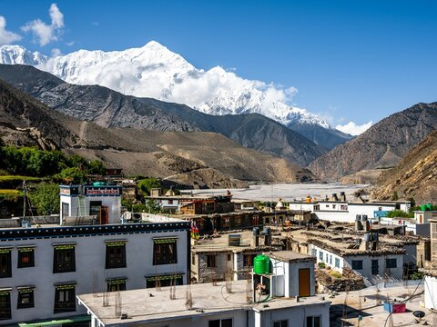  Traditional mud-brick buildings and new concrete structures in Kagbeni. Road access has accelerated incompatible development.  Tourism Arrivals Annual Pilgrims to Muktinath  ~2,000/yr (1992) ~20,000/yr (pre-road)  ~15,000+/yr (2019) 200,000+/yr (2019)  Tourism arrivals 7× growth (1992–2019); Muktinath pilgrimage 10× growth post-road

② Environment, Ecosystem & Biodiversity
The Kali Gandaki gorge corridor is among Asia's most important raptor and waterbird migration routes. The arid badlands support specialist species assemblages found nowhere else in Nepal. However, the post-road expansion of tourism infrastructure, combined with increased grazing pressure as agropastoralism intensifies, is pushing land degradation. Fuelwood collection from juniper woodland above 4,000m continues despite ACAP regulations.  The 2023 flood event deposited ~647,000 m³ of debris through Kagbeni, radically altering the riverbed morphology, burying agricultural land, destroying orchards, and creating new erosion channels that threaten the stability of the ancient town's foundations. River-bank settlements remain highly exposed to future events as the Jhong Khola continues to change course.  Shaligram Fossil Heritage: The Kali Gandaki riverbed between Kagbeni and Muktinath is the world's only source of Shaligram ammonite fossils — venerated by Hindus and Buddhists for 2,000+ years. Glacier retreat is reducing river flow and shifting the river away from fossil-bearing shale beds, threatening availability of these sacred stones. Gravel mining by road construction further accelerates this erosion. | 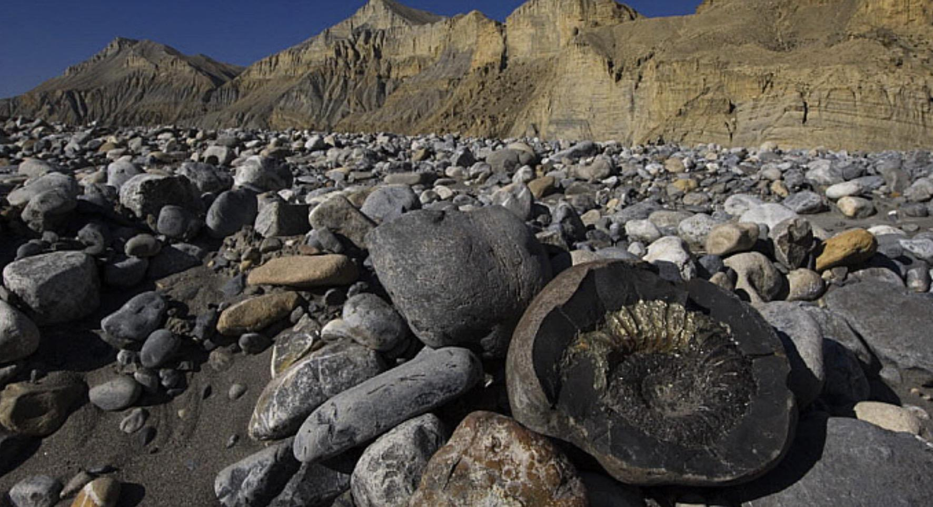The Kali Gandaki riverbed near Kagbeni — source of sacred Shaligram ammonite fossils, now threatened by glacial retreat and gravel mining.

③ Climate Change, Hazards & Resilience
🌊 Flash Flood & Landslide Dam Burst  • August 2023: landslide dam-burst flood destroyed 29 buildings; USD 7.4M damage  • Jhong Khola catchment (fragile Spiti shale) highly susceptible to rapid mass movement  • Arabian Sea warming pushing monsoon clouds northward — unprecedented rain-shadow flooding  • Rebuilt in flood-plains: locals returning to high-risk sites; no government embankment  • Community warning system saved lives in 2023 — remains informal and unfunded | ⛰ Wind Erosion & River Bank Erosion  • Constant high-altitude winds (Nov–Mar) carve ochre cliffs and damage structures  • Kali Gandaki bank erosion accelerating — settlements on river margins at rising risk  • Ancient mud-brick architecture dissolving under increased rainfall — 'buildings that survived centuries now failing'  • Increased river erosion from GLOF events undermining terraced farmland  • Road construction disturbs fragile shale slopes, triggering additional landslide pathways
🌡 Drought, Frost & Water Scarcity  • Spring frosts increasingly erratic — threatening barley germination and apple blossom  • Glacier retreat reducing Kali Gandaki baseflow; irrigation insecurity rising  • Hailstorms can destroy entire barley/buckwheat harvest within minutes  • Muktinath tourism water demand competing with irrigation supply  • Snowpack decline reduces soil moisture recharge for spring planting | 🟨 Cultural & Spiritual Heritage Loss  • Kag Chode Monastery (est. 1429) — roof and walls vulnerable to increased rainfall erosion  • Shaligram fossil beds becoming inaccessible as river shifts and glacier retreats  • Ancient mud-brick houses of medieval Kagbeni cannot withstand new rainfall regime  • Rapid commercialisation changing character of pilgrim-hospice tradition  • Loss of Baragaonle youth to cities — traditional ecological knowledge and water management at risk

Indigenous Resilience Systems
- Traditional water-sharing governance — rotational irrigation rights between households; analogous to Upper Mustang's Ghenba system; 800+ year-old design still functioning
- Sowa Rigpa (Amchi medicine) — Tibetan traditional medicine practised in Baragaon villages; primary healthcare where government services are absent or seasonal
- Muktinath interfaith convergence — the only site in the Himalayas with simultaneous Hindu and Buddhist sacred significance; 108-spout bathing rite, eternal flame, and Shaligram pilgrimage reinforce conservation ethic around water sources
- Community flood early-warning network — informal warnings from upriver villages saved all lives in August 2023 disaster; demonstrates living social infrastructure
- Yartong and Dashain festivals — local festivals maintaining social cohesion and seasonal governance; Baragaonle oral traditions encode ecological knowledge of river behaviour and pasture management

Health Profile
Kagbeni's health burden reflects a community in rapid epidemiological transition — accelerated by road access and mass tourism. The traditional burden of altitude-related and infectious disease is being overlaid by rising non-communicable diseases driven by dietary change (processed foods from Chinese and Indian traders), physical inactivity changes, and psychosocial disruption from cultural commercialisation.  Public Health Highlights: Acute Mountain Sickness affects 25–40% of rapid-ascent pilgrims at Muktinath (3,760m). No sewage infrastructure — fecal contamination of water sources certain. UV radiation 2–3× sea-level intensity. Nearest hospital: Jomsom (~8km south); emergency helicopter from Pokhara. Post-2023 flood: water source contamination elevated across Kagbeni. dra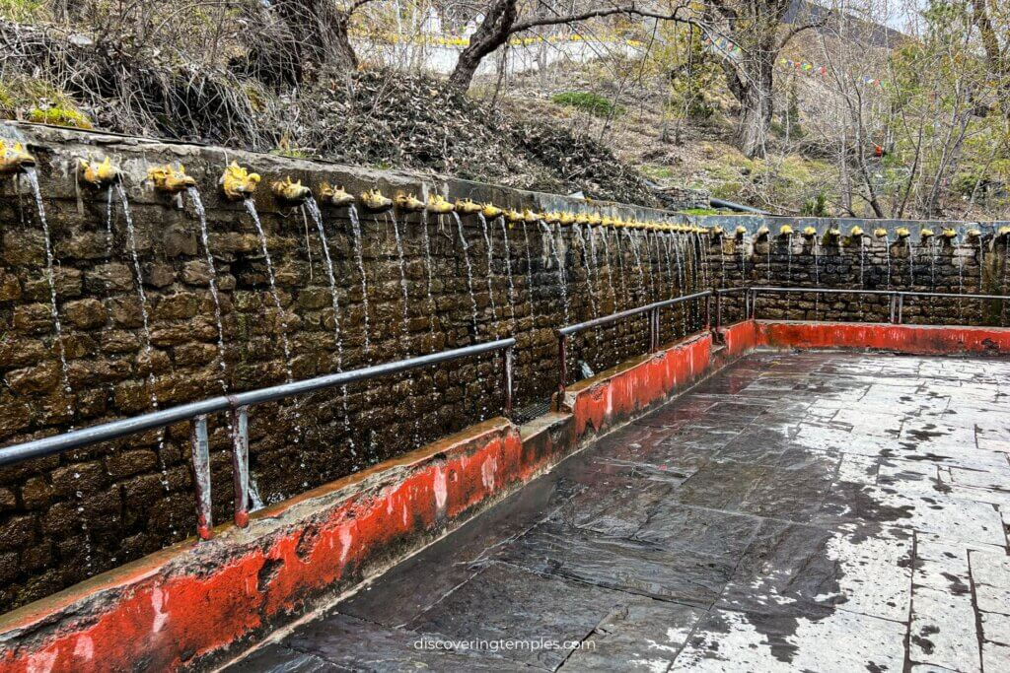  108 sacred waterspouts that draw hundreds of thousands of pilgrims annually. | 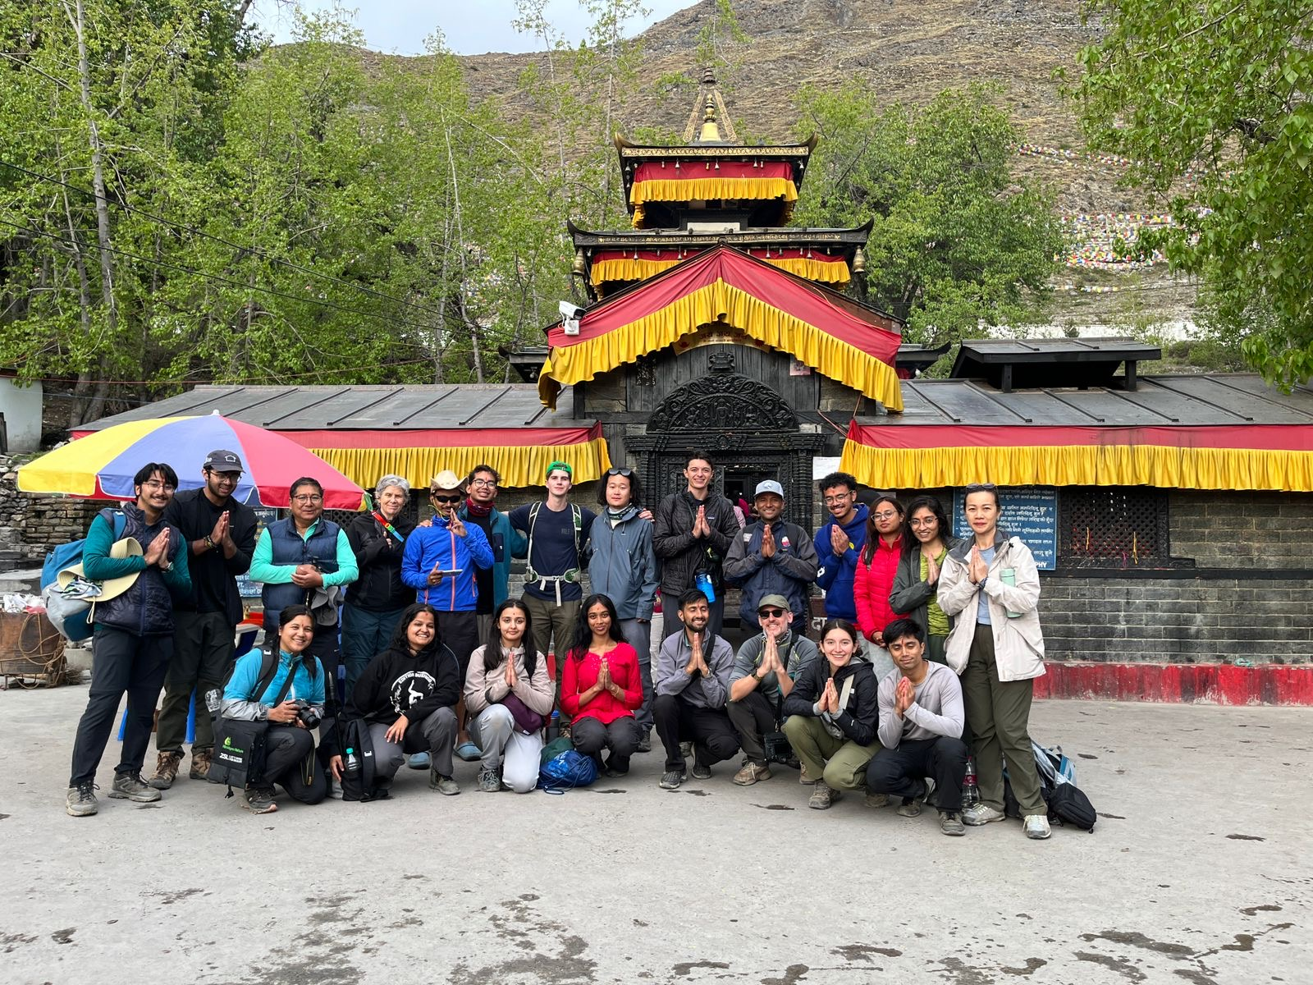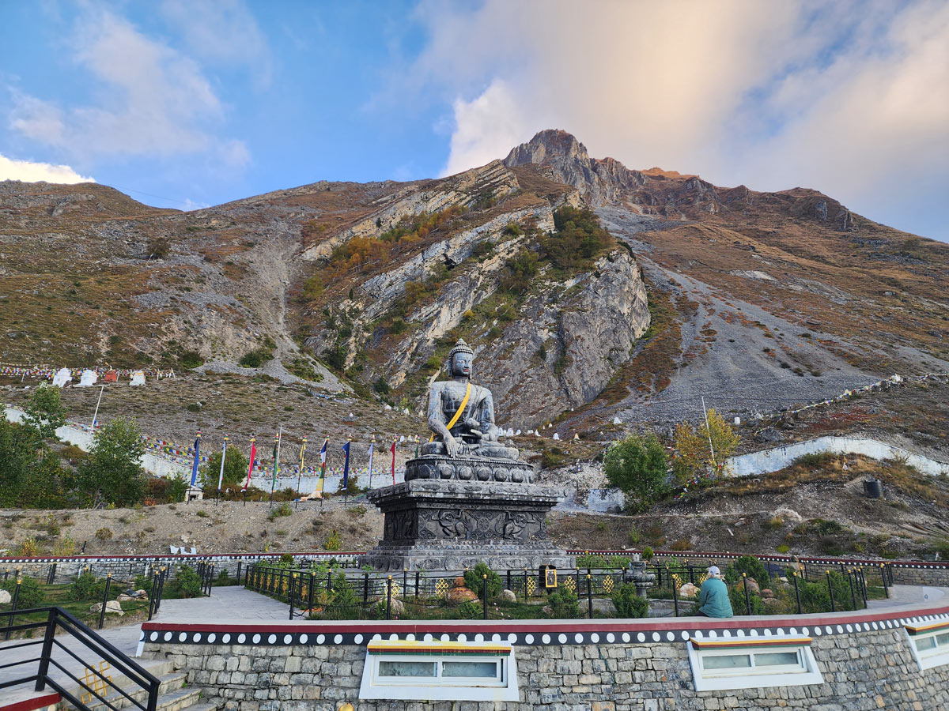Muktinath temple (3,760m) — sacred to Hindus, Buddhists and Bon practitioners.

⛰ Altitude & AMS/HAPE  At Muktinath (3,760m), Acute Mountain Sickness affects 25–40% of rapid-ascent pilgrims — the majority of Muktinath's 200,000+ annual visitors arrive by jeep within hours from Pokhara, allowing no acclimatization. HAPE is a medical emergency risk. Loba and Baragaonle populations carry EPAS1 genetic adaptation to hypoxia. Nearest hospital: Jomsom (~8km south of Kagbeni). Emergency evacuation requires helicopter from Pokhara. | 💧 Water Quality & Zoonotic Risk  No sewage infrastructure in Kagbeni — raw waste enters Kali Gandaki. Post-2023 flood: riverbed massively disturbed, spring and well contamination likely elevated but untested. Yak and livestock herding community maintains close human-animal interface. Pilgrim crowds at Muktinath (108 water spouts bathing) create mass-gatherings epidemiological risk. Open border with Tibet historically creates cross-border disease transmission pathways.
🏙 Non-Communicable Disease  Post-road access is driving dietary change — processed food, salt, sugar from Indian and Chinese traders. NCD risk factors (hypertension, obesity, diabetes) rising across all age groups. UV radiation 2–3× sea-level intensity elevates cataract and skin cancer risk — particularly for pilgrims bathing outdoors at Muktinath. Cardiovascular disease and COPD are the national leaders; the trend is mirrored locally. | 🧠 Mental Health  Depression: 11–17% of adults nationally; treatment gap >90% mirrored locally. Rapid cultural disruption — commercialisation of the pilgrim-host tradition, youth diaspora, loss of trans-Himalayan trade identity, post-flood trauma — drives psychosocial stress. Community grief following the 2023 flood (families displaced 9+ months with no government response) is significant and unaddressed. Buddhist practice and community festivals remain key protective factors. (Luitel et al., 2017; 2018)

Cross-Cutting Themes
GEDSI  Gender, Equity, Disability, Social Inclusion: growing proportion of female-headed households as male migration accelerates. Post-road in-migration has introduced new social hierarchies alongside traditional Baragaonle class structures. Literacy gap persists (male >female). Disability and elderly populations face acute barriers to healthcare (8km to Jomsom hospital). Post-flood displaced households disproportionately low-income. GEDSI lens essential for equitable heritage conservation, climate adaptation, and pilgrimage-economy benefit distribution. | Mental Health & Wellbeing  Rapid cultural commercialisation — transformation of sacred pilgrimage infrastructure into mass-market tourism, loss of Baragaonle youth to cities, post-2023 flood trauma — drives psychosocial disruption and ecological grief. Treatment gap >90% mirrors national trend. Community flood response demonstrated remarkable mutual aid ('from Upper Mustang to Lower Mustang, all communities came'). Buddhist practice, monastery community structure, and festivals remain key protective factors. (Luitel et al., 2017; Jordans et al., 2020) | Culture, Heritage & Human–Nature  Kagbeni: 12th-century gateway town; active medieval monastery (est. 1429); ACAP-managed landscape. Shaligram fossil pilgrimage encodes a 2,000-year human–river relationship now threatened by glacial retreat and river-course change. Muktinath as interfaith convergence site (Hindu, Buddhist, Bon) represents unique planetary health asset — spiritual site whose ecological health is inseparable from its religious function. Kali Gandaki water ethic embedded in pilgrimage narratives mirrors the Tiji Festival water ethic in Upper Mustang.

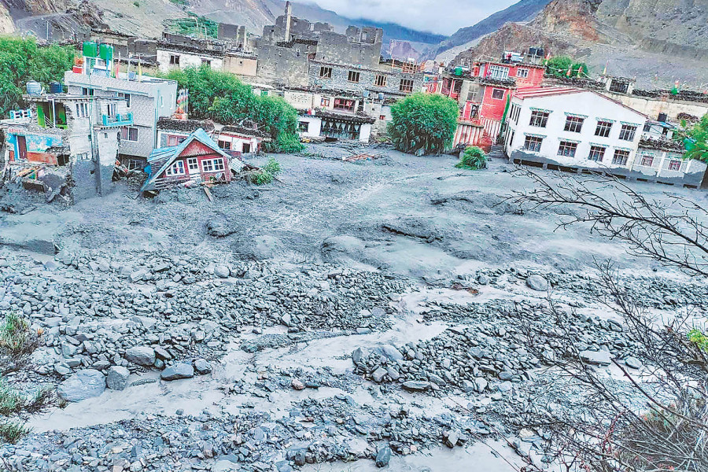Kagbeni flood aftermath (August 2023) — 647,000 m³ of debris deposited. | 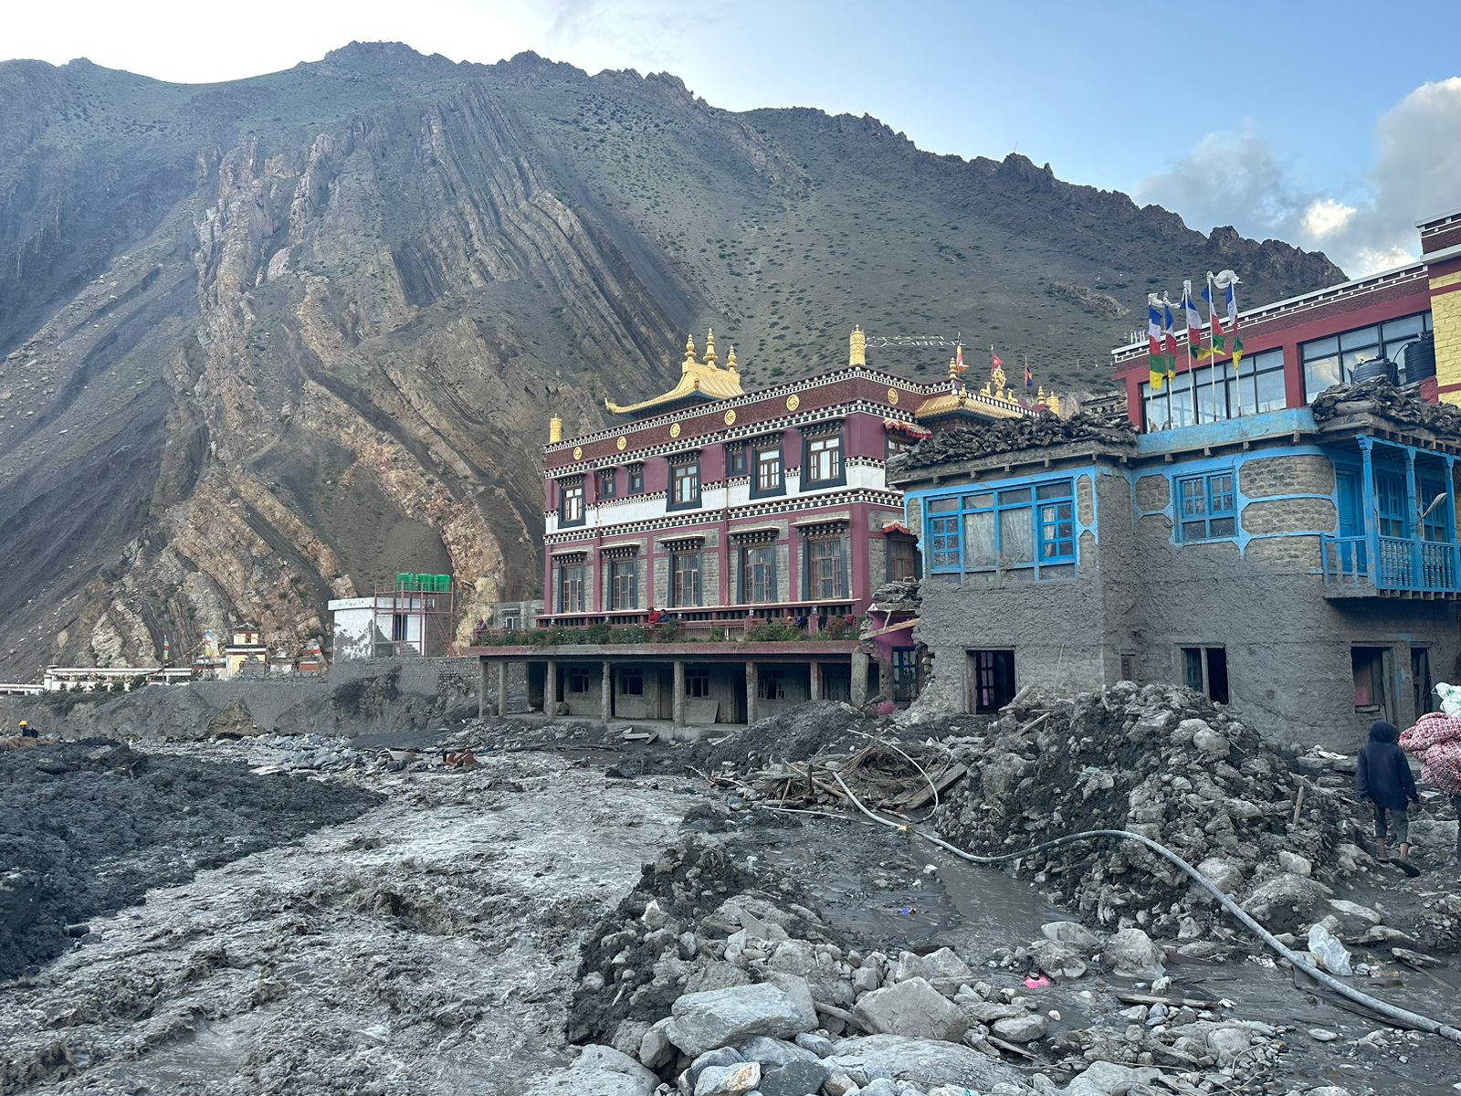

Sources
Mustang District Wikipedia / Nepal Census 2001, 2011, 2021 — Mustang District • Kagbeni, Mustang — Wikipedia • Gharapjhong & Baragung Muktichhetra Rural Municipality Profiles • Fort M. et al. (2025) — Kagbeni flood event, Geomorphologie journal • ICIMOD Baseline Data (2023) — Climate information services, Nepal • Khattri et al. (2021) — Climate trends, Trans-Himalayan zone • McDermott et al. (2011) — Arsenic, Mustang water supply • Walters H. (2023) — Shaligram pilgrimage and climate change, The Conversation • Mongabay / Abhaya Raj Joshi (2024–2025) — Tourism and climate change, Mustang • The Nation / Wen Stephenson (2024) — Climate loss and damage, Mustang • Kathmandu Post (2024) — Kagbeni flood aftermath • Annapurna Express (2024) — Flood displaced persons, Kagbeni • ACAP / NTNC / DNPWC documentation • Luitel et al. (2017; 2018) — Mental health treatment gap, Nepal • Jordans et al. (2020) — Mental health, Nepal

